# ITEF Organization

The ITEF model assumes the use of lean organizations capable of maximizing overall responsiveness and agility. The solution takes shape from the experiences gained by AlmavivA with the AlmaToolBox® solution in the field of management consulting in the DevOps & Digital Optimization area, from the models proposed by Jeff Anderson and from advanced organization models such as those of Spotify®.

As expected for agile DevOps organizations, Project Teams are dedicated teams that form an independent team (Squad). Within each Squad are all the skills needed to implement the service. Each Squad moves as if it were a Rowing Team. Inside the Team there is the figure of the "Rowing's Stroke", which expands the normal task of the Scrum Master Scrum (to interact with the members of the Scrum Team - Product Owner and Development Team - and with the entire organization in order to maximize the value created by the Scrum Team, to protect the team from interruptions during the sprint, to facilitate the problem solution) inserting also the task to set and refine the performance of the team constantly optimizing it against the expected goals. It's good here not to fall into the trap for which with this further attribution the Scrum Master dusts off the figure of the Project Manager with relative satisfaction of the nostalgic of old models and processes: the new attribution if anything emphasizes even more the role of coaching that every actor of the company management must have in order to allow a continuous progress and a continuous improvement of the teams.

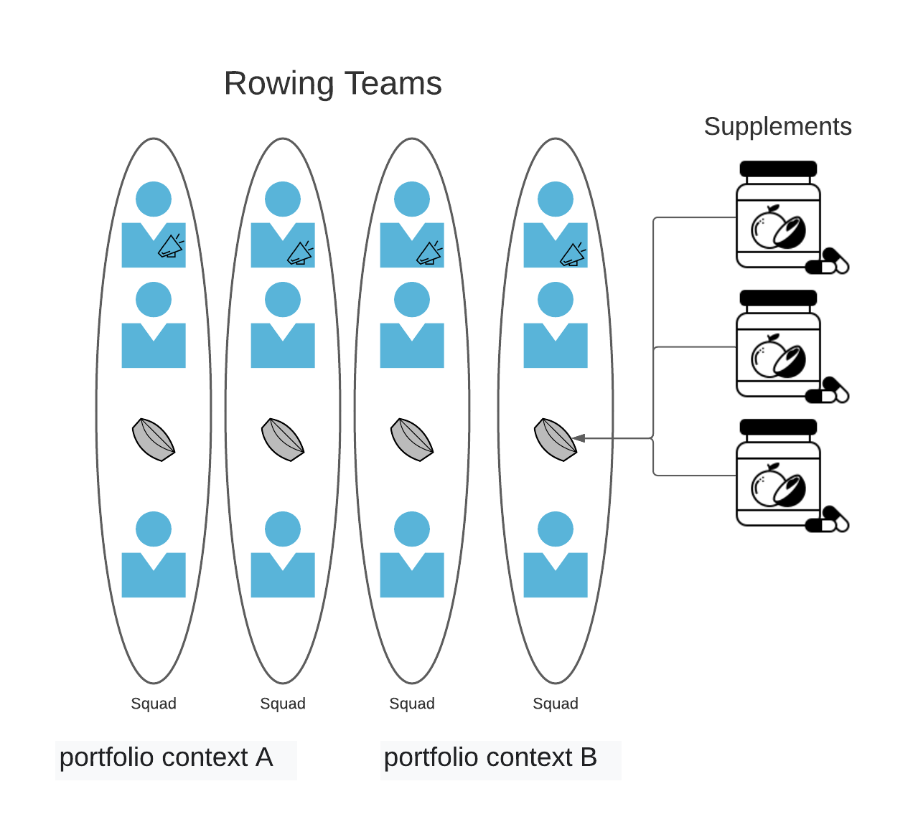

Rowing teams, organized in Squad, can be correlated within a portfolio area in order to ensure a better coordination of the initiatives that are expected to be carried out according to the model proposed by SAFe® version 5.0. With respect to the latter, the model described addresses in particular the organization in the "Essential" area of SAFe.

Since many of the necessary activities within a Rowing Team cannot be carried out with people dedicated in a full way on the single project, the organizational model provides the "Supplements", a sort of "vitamins" to be given to the Squad so that they arrive happily to the finish line overcoming all the efforts and obstacles.

The Supplements operate substantially as a sort of "external service providers" able to provide services to catalog in times, ways, quality levels and pre-defined costs. The model calls for a "supplement handbook" that contains at minimum the following data:

* Services
* Method of request
* Taking charge time
* Processing time
* Costs

The Team "supplements" work according to the kanban process and use Lean IT with the aim of optimizing their operation in order to achieve Just in time. The individual Rowing Teams can then have a complete rowing team obtained as a union between Squad and services offered by supplements.

It is the task of the two components GEL and GPO to make sure that this mechanism works at its best with a double objective:

- Optimize the production with respect to the service to be provided (quality, time and costs)

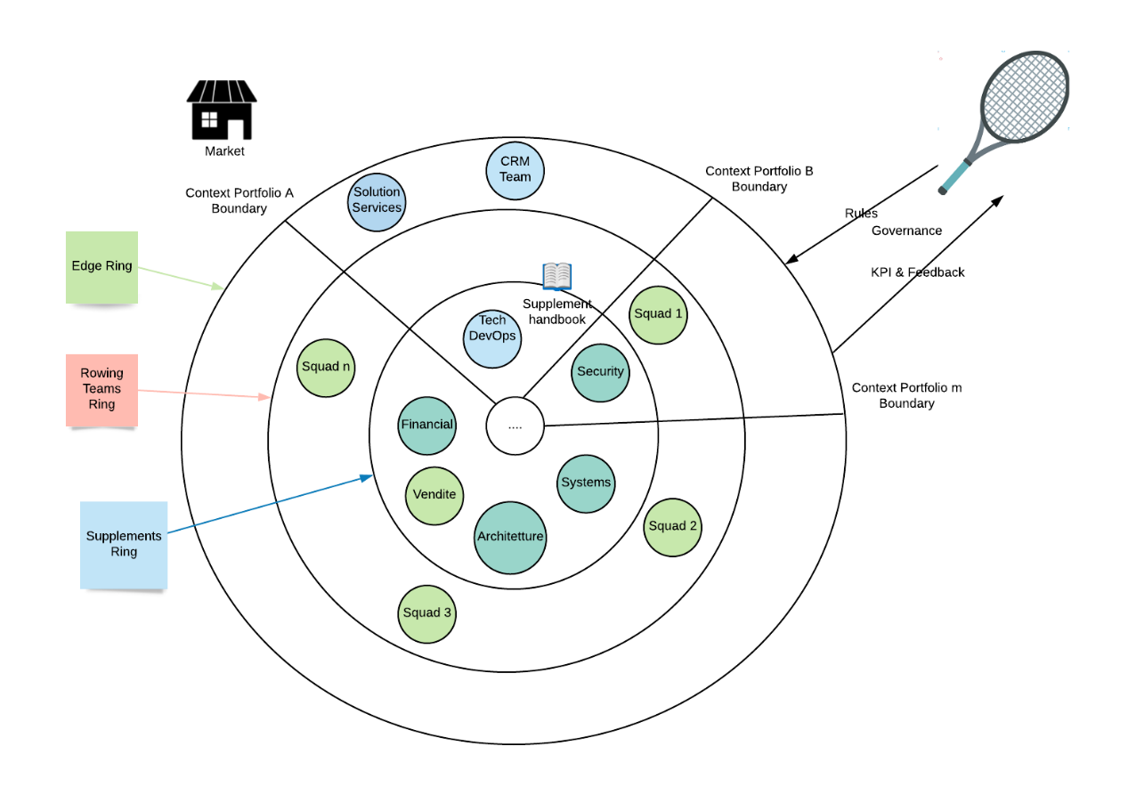- Optimize production with respect to the principle of Green First

The overall organization of a company can be described with an organization chart in rings that make up a single "ball". Outside the ball there is the Governance component whose task is to give the "ball" the right direction to win all the market challenges including green objectives to be achieved.

Governance gives the right direction to the ball through the "Rules" and monitors its progress through "continuous feedback with KPIs".

The "ball" is a concentric set of spheres that for simplicity we represent as a "ring". The innermost ring is the one dedicated to the "supplements" that we learned about a few steps back in this paragraph. In this ring there are, first of all, those teams that could not insert their own personnel in all the projects because these are very numerous, and the activities foreseen by a project would not allow to have dedicated resources with specialized skills only in certain areas. This sphere also includes all the offices that are indirectly involved in the value chain but that support its correct functioning, such as the marketing and sales offices, administration, HR, etc. In this way, the client can be assured that they will be able to take advantage of the opportunities offered by the service.

The immediate outer ring is the "Rowing Teams Ring", i.e. the ring that contains all the project teams. These can be grouped by context boundary which normally refers to a specific portfolio area. The Rowing Teams Ring interacts with the supplements ring on the basis of the supplement handbook that defines the catalogue of services and relative OLAs.

The outermost ring is the one that communicates directly with the Marketplace. It is at this level that we find the Solution Services dedicated to the management of demand or scope such as those of CRM that are placed as a single interface to the activities of management and support.



**The organizational model ITEF is aimed at obtaining the maximum efficiency of operation of the company that can produce in extremely agile mode and with high reduction of waste. For this reason an endowed company of this organization is a company that has completed an ulterior step Green*.***